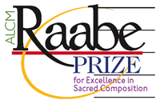
2019 Raabe Prize Submission Form

Please complete the information below, save the document in either Word or PDF format, and email to raabeprize@alcm.org with two electronic copies of the submitted work (PDF preferred) – one unattributed (without the composer’s name and, if published, all publisher’s markings) and one with the composer’s name. In addition to the required musical scores, composers are encouraged to submit a recording of the work. Please also be sure that the composer’s name does not appear on the recording. Submissions for the 2019 award must be received by October 1, 2018.

Composer name:

Composer address:

Composer email:

Composer phone:

Submitted by (if different from above):

Submitter’s email:

Submissions for the Raabe Prize should “reflect a larger history of excellence on the part of the composer.” Please list below or as an attachment the composer’s additional published or unpublished works and/or awards that support this submission.

