Hymn Festival

Wild Life

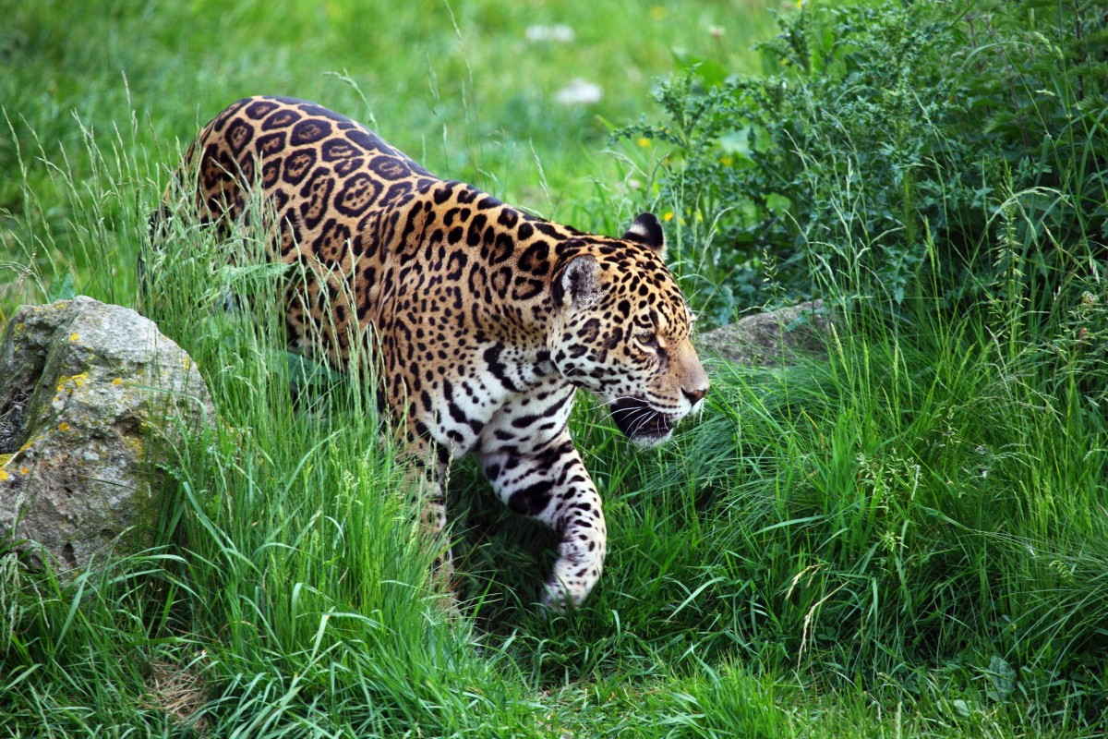

Notes: Music area for a few singers, percussion and piano. Font in the center on floor. Stations for rocks, sand and candles.

Human resources: song leaders, keyboardist(s), flute or other treble instrument

Other resources: rocks, sand and candles, egg shakers, finger cymbals, gong, djembe

Note: Hymns suggested throughout come from *All Creation Sings (ACS), Evangelical Lutheran Worship (ELW), and Lutheran Service Book (LSB.)*

Introduction –

A hymn festival is a distinctively Lutheran invention creating a conversation between music and community. Sharing songs from every time in history and every cultural community, we learn melody, words, and rhythms not necessarily our own. In the spoken dialog we are encouraged to explore thoughts and ideas not familiar to us. Together, we are transported into the creativity and spiritual expression of our sisters and brothers across the globe.

As we sing, ponder, and pray, our hearts align with the grand design of our Architect Creator. When we open to a world of beauty, we are filled with awe and humbled to the core of our being. Is there a greater worship we can offer?

Wild Life, a Hymn Festival, invites us to blend our one small voice with the voices of Eternity –the artists, cultures, earth forms, and opportunities that God spun into existence because we are loved.

**ELW 171 Heleluyan** - Muscogee (Creek)

Alternate options include Halle, Halle, Hallelujah (ELW 172), 173 or 174, LSB 951, 952

**Creation**

**Reading –**

Entering into the vision and love of God alters our perception of reality. Allow me to test that thought. In what voice does the Maker of All Things speak to you? What or who informs you about the goodness of God? When and where does the Spirit access your heart-center…your soul? And how do you embody the vision and love poured into Creation?

St. Francis of Assisi found the answer by widening his vision to include all creatures – the whole order of Creation. He focused on the Divine Architecture of sun, moon, stars, birds, bugs, and rocks. Everything. He said, “If there are people who will exclude any of God’s creatures from the shelter of compassion and pity, you will have those who will do likewise with their neighbor.”

**ELW 835 All Creatures Worship God Most High - stanza 1**- St. Francis text, Germany tune

Reading –

The architecture of the natural world reveals a “circle of life,” central to the Native

American understanding of Creation. The round shape recognizes the interconnectedness of all living beings and holds within its frame life’s infinite possibility, unity, and wholeness. It is often seen as a symbol of God’s nurture and protection – like the womb that holds new life. Listen to Song of the Sky Loom by Tewa poet, Roxanne Dunbar-Ortiz:

O our Mother, the Earth,

O our Father, the Sky,

Your children are we, and with tired backs

We bring you the gifts that you love.

Then weave for us a garment of brightness;

May the warp be the white light of morning,

May the weft be the red light of evening,

May the fringes be the falling rain,

May the border be the standing rainbow.

Thus weave for us a garment of brightness,

That we may walk fittingly where birds sing,

That we may walk fittingly where grass is green,

O our Mother Earth,

O our Father Sky.

Echoing the words of St. Francis – poets like Ms. Dunbar-Ortiz teach us what it means to embody a kind of interdependency sustained within the circle of earth and sky, human life and productivity. ALL creation sings the Spirit’s presence – a melody so sweet and beautiful that the heart willingly intertwines with the warp, weft, and fringe of holy brightness…listen.

**943 As the Wind Song** - New Zealand text, Singapore tune   
**use flute, gong, ching, finger cymbals if possible**

**Other options: ELW 396 Spirit of Gentleness, X Breathe on Me, Breath of God**

Reading –

There is such a thing as the ‘beauty way.’ Esther tells the story to visitors who come

deep into Canyon de Chelly. Reminiscent of the great Ansel Adams photo, Esther sits at her loom all day, surrounded by knots of hand-dyed wool. While she works, she says the canyon walls talk to her with the voices of her ancestors who lived and suffered atrocities there. With each pass of her shuttle, she practices the Beauty Way, so that what she weaves tells a new, resilient story to her children and grandchildren.

Read in English and Navaho if possible

In beauty I walk

With beauty before me I walk

With beauty behind me I walk

With beauty above me I walk

With beauty around me I walk

It has become beauty again

It has become beauty again

It has become beauty again

It has become beauty again

Hózhóogo naasháa doo

Shitsijí’ hózhóogo naasháa doo

Shikéédéé hózhóogo naasháa doo

Shideigi hózhóogo naasháa doo

T’áá altso shinaagóó hózhóogo naasháa doo

Hózhó náhásdlíí’

Hózhó náhásdlíí’

Hózhó náhásdlíí’

Hózhó náhásdlíí’

**ACS 1071 In Sacred Manner** -

introduction flute;

singers sing stanza 1, then all repeat stanza 1

Alternate options: ELW 736 God, the Sculptor of the Mountains

ELW 879, For the Beauty of the Earth

LSB 894 For the Fruits of His Creation

**Water**

Reading –

In the center of the room is the font filled with what we like to call ‘the water of life.’ St.

Francis of Assisi summoned the creator saying: “Be praised, my Lord, through Sister Water; she is very useful, and humble, and precious, and pure.”

By observing the nature of water, St. Francis learned to honor God as the architect of all that gives life. Water circulates in this world limitlessly – industriously absorbing and dissolving all contaminants. Water, all by itself, does for us that which we cannot do for ourselves. Science has proven that now – but long ago St. Francis had already sung in his heart what he spiritually and intuitively ‘knew’ to be true; all creatures…all things mirror the goodness of the Creator.

**ELW 835 All Creatures** - stanzas 2 and 3

Reading –

For billions of years, water has been carving out impressive canyons, nurturing trees

in endless variety, assisting spiders to spin one of earth’s strongest materials into a complex web, or crystalizing into a slab of granite that sparkles in the sunlight. Too often, we fail to notice water’s creative genius. Staring at our phone or computer, we isolate ourselves from the wild world, cutting ourselves off from a powerful source of inspiration, delight, and wonder.

The font is central among us, filled with the water of life. Consider it an invitation to reconnect and rekindle your sense of awe. Come forward to touch and be refreshed in its water. Allow melody, poetry, and rhythm to teach you, widen your trust, and broaden your understanding of the Great Creator’s promise of life and salvation. Come.

**ACS 982 Many Will Come from East and West** - United States

All sing once together from the front, then cantors lead canon in 2 sections

Alternate option: In Christ There Is No East or West – ELW 650; LSB 653

**ACS 957 Take Me to the Water** - African American Spiritual

Alternate Option – ELW 456 Baptized in Water

**ACS 955 Come to the Water of Life** - United States (as needed)

**ACS 1071 In Sacred Manner** - short intro flute;

all sing stanzas 2-4

**Word**

Reading –

Jesus said, “If you abide in me and my words abide in you, ask for whatever you wish,

and it will be done for you.”

What does ‘abide’ mean to you? When we sing together, are we ‘abiding’ with each other, with the words, or hearing anew the promises of God? When we ‘abide’ in nature, do we imagine ourselves at one with the tree, the wind, the birds, the sun?

What has formed your theological concept of abiding? For those whose whole existence is formed differently – how will they hear the Gospel’s invitation to abide?

St. Francis summed it up this way: “Preach the Gospel, use words when necessary.”

**ACS 972 Listen Now for the Gospel** - Zimbabwe

Djembe on half-notes;

1 cantor sings the leader part; the rest of the cantors sing in parts

Alternate option: ELW 513; LSB 833 Listen, God Is Calling

Gospel Reading: John 15:1-11 (Vine and Branches)

**ACS 1023 God Alone Be Praised** - United States- keyboard and flute

**Rocks**

Reading –

God’s Word reveals the infrastructure of all creation. “I tell you, if these were silent, the stones would cry out.” Jesus offers us an image of a seeming impossibility - talking rocks. Or is it impossible? Does the Grand Canyon speak? What about Esther who hears the voices of her ancestors in Canyon de Chelly, teaching her to nurture the generations to come?

This time, come forward to choose a rock that best describes your inner life…your prayer life. Some of the rocks are smooth, some jagged, some heavy, some beautiful. As you choose a stone, ponder this: Precious gemstones and minerals may have built much of the world’s wealth, but it is the more humble minerals that are priceless. Without them life would not exist.

Simple Calcium leaches from limestone into the soil, is absorbed by plants as life-giving fertilizer– your own body uses Calcium to build cell walls. In God’s design of Creation, the material world and every living thing rises from a foundation of ingenious building blocks not made by human hands.

**ACS 1024 Here on Jesus Christ I Will Stand/Krake Yesu masimama** -Kenya

Cantors sing in parts, then all repeat. English and acapella

Keyboard support song if needed

**ACS 947 Source and Sovereign, Rock and Cloud** - text United States, tune England

**Alternate Option – ELW 596, 597, LSB 575, 576 My Hope is Built in Nothing Less**

**ACS 1071 In Sacred Manner** -

short intro on flute: then stanza 5

**Prayer**

**Following the reading, people can light a candle at the sand stations**

Reading

Pope Francis chose to be called after St. Francis of Assisi saying, “St. Francis was the

man of poverty, the man of peace, the man who loves and protects Creation, the same created world with which we don’t have such a good relationship.”

As we enter a time of prayerful song, you are invited to come light a candle at one of the sand stations. There you may offer your petitions for a world in need. “All the darkness in the world cannot extinguish the light of a single candle.” Wise words from St. Francis.

**ACS 1009 Come Bring Your Burdens to God**

Cantors - sing in parts

**ELW 800 Spirit of God, Descend Upon My Heart**

And/or

**ACS 1067 For the Wholeness of the Earth**

**ACS 1071 In Sacred Manner** - stanza 6 - flute only

**ACS 1033 Nothing Can Trouble/Nada te turbe** (if needed) text Teresa of Avila, music Taizé

All in Spanish; cantors sing in parts, piano first time, then drops out if singing is strong enough

Reading from St. Francis

We take our leave with one last thought from St. Francis: “All things of creation are children of the Creator and thus brothers and sisters. God wants us to help animals if they need help. Every creature in distress has the same right to be protected.” “Ask the beasts, and they will teach you the beauty of this earth.”

**Sending**

**ACS 989 Let Your Peace Rain upon Us/Yarabba ssalami**

Sung by the cantors in Arabic, acapella

Alternation Option – ELW 547; LSB 643 Sent Forth By God’s Blessing

Spoken Benediction

May the God of steadfastness and encouragement grant you to live in harmony with one another, in accordance with Christ Jesus . . . May the God of hope fill you with all joy and peace in believing.

**ELW 835 All Creatures, stanzas 4- 6** - singers lead the recession as all are singing